**Group Number**: 1

**Group Members**: Anshuman Pradhan, Yash Manish Dodia, Karan Mehta, Nageshwari Reddy Vangala

**Walmart Online Shopping Platform**

1. **Company Description:**

Walmart is an online e-commerce platform that operates a chain of hypermarkets (also called supercenters), discount department stores, and grocery stores from the United States, headquartered in Bentonville, Arkansas. The company was founded by Sam Walton in nearby Rogers, Arkansas in 1962 and incorporated under Delaware General Corporation Law on October 31, 1969. People use Walmart to order food, consumables and general merchandise assortment such as groceries, everyday essentials, toys and electronics.

1. **User Requirements:**

Below entities comprise of overall user requirements and data needs to be recorded for the same:

1. User
   1. UserID (Unique Identification for User)
   2. Password (Account Login Password)
   3. First Name
   4. Last Name
   5. Phone Number (user can have more than one phone number)
   6. Email (user can have more than one email)
   7. Address
   8. Date of Birth
   9. Account Type

Users have an option to enroll for Walmart Plus account type to avail benefits on product. Walmart Plus members are entitled to receive discount offers.

1. Product
   1. ProductID (Unique Identification of each Product
   2. Product Name
   3. Product Description
   4. Product Price
   5. Product Category
2. Order
   1. OrderID (Uniquely Identification for each Order
   2. Order Date
   3. Order Time
   4. Amount
   5. Order Status
3. Payment
   1. PaymentID (Unique Identification for every payment made by user)
   2. Payment Date
   3. Payment Time
   4. Amount
   5. Mode of Payment
4. Seller
   1. SellerID (Unique Identification of each Seller)
   2. Seller Name
   3. Address
   4. Reviews
5. Discount
   1. DiscountID (Unique Identification of each Discount applied)
   2. Validity
   3. Discount Type

There are 2 discount type which is Regular (normal day discount offer) and special discount (seasonal or festive discount offer).

1. User can select one or multiple products while shopping. One product can be selected by multiple users at same time.
2. User can place one or multiple orders.

**Assumption**: Only one order should lead to one customer at a given time.

1. User can make one or multiple payments for an order. However, at a given time only one payment should be done by one user.
2. One payment should be associated to only one order.
3. A Seller can receive none or many orders. At a given time, one order should relate to only one seller.
4. Multiple products can be sold by one seller. A given product can be sold by multiple sellers at a given time.
5. User can give review to none or many products.
6. User can give review to none or many sellers.
7. One order can have one or multiple products at a given time.
8. Discount is applicable only to Walmart Plus members. A regular member is not eligible to receive discount offers.
9. User can have 2 account types, Normal or Walmart Plus. Walmart Plus members are entitled to receive discount offers.
10. At a given time, only one offer can be availed by one Walmart Plus user. It can be Regular offer or Special offer depending on user preference.
11. **Entity-Relationship Diagram** (updated as per BB comments)

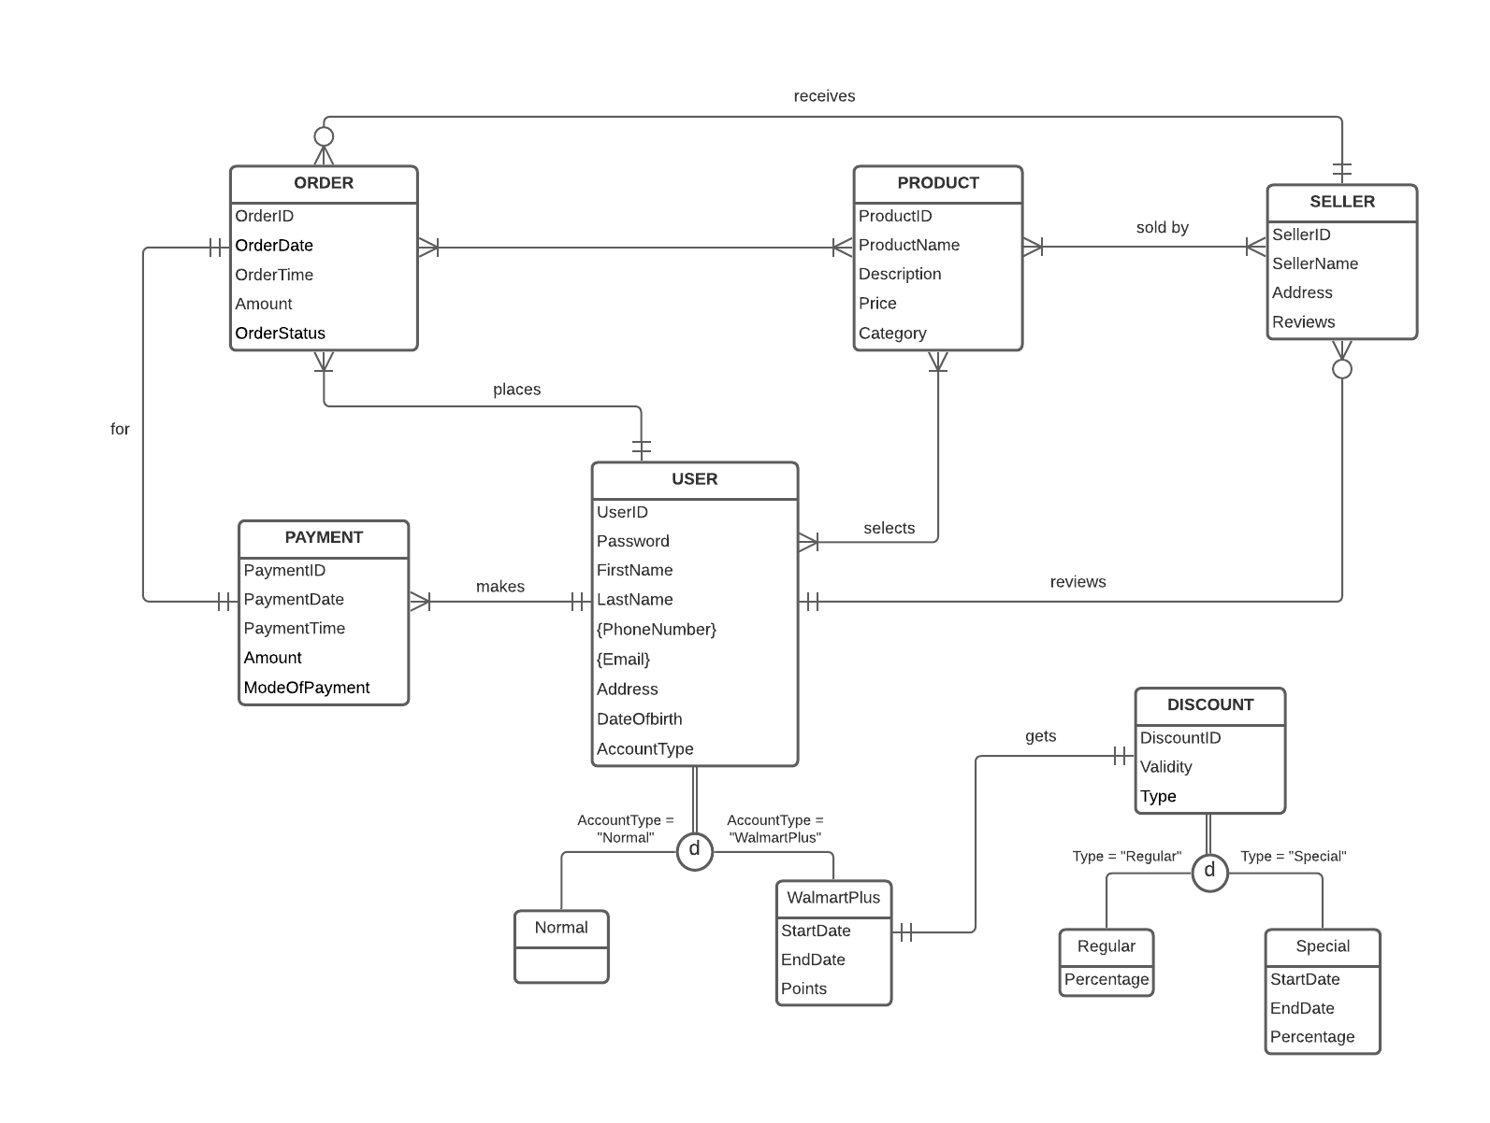

1. **Relational Data Model**

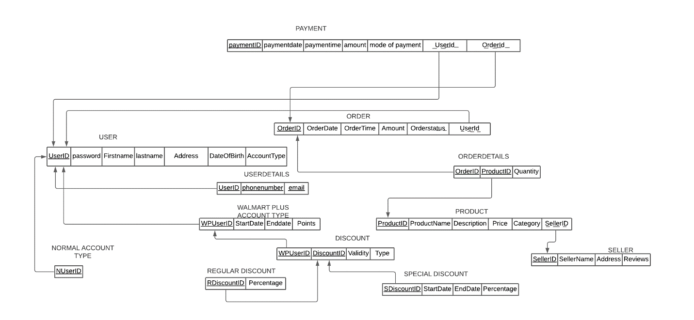

1. **Metadata**

User_t

|  |  |  |  |
| --- | --- | --- | --- |
| **Attribute** | **DataType** | **Size** | **Constraint** |
| UserID | INT | 10 | Primary Key |
| Password | VARCHAR | 30 |  |
| FirstName | VARCHAR | 50 |  |
| LastName | VARCHAR | 50 |  |
| Address | VARCHAR | 100 |  |
| DOB Date | VARCHAR | 30 |  |
| Account Type | VARCHAR | 30 |  |

Seller_t

|  |  |  |  |
| --- | --- | --- | --- |
| **Attribute** | **DataType** | **Size** | **Constraint** |
| SellerID | INT | 10 | Primary Key |
| SellerName | VARCHAR | 30 |  |
| Address | VARCHAR | 50 |  |
| Reviews | VARCHAR | 50 |  |

User_details_t

|  |  |  |  |
| --- | --- | --- | --- |
| **Attribute** | **DataType** | **Size** | **Constraint** |
| UserID | INT | 10 | PRIMARY KEY, FOREIGN KEY |
| PhoneNumber | VARCHAR | 15 | PRIMARY KEY |
| Email | VARCHAR | 50 | PRIMARY KEY |

Product_t

|  |  |  |  |
| --- | --- | --- | --- |
| **Attribute** | **DataType** | **Size** | **Constraint** |
| ProductID | INT | 10 | PRIMARY KEY |
| ProductName | VARCHAR | 30 |  |
| Description | VARCHAR | 50 |  |
| Price | INT | 10 |  |
| Category | VARCHAR | 30 |  |
| SellerID | INT | 10 | FOREIGN KEY |

order_t

|  |  |  |  |
| --- | --- | --- | --- |
| **Attribute** | **DataType** | **Size** | **Constraint** |
| OrderID | INT | 10 | PRIMARY KEY |
| OrderDate | DATE |  |  |
| OrderTime | VARCHAR | 50 |  |
| Amount | INT | 10 |  |
| OrderStatus | VARCHAR | 30 |  |
| UserID | INT | 10 | FOREIGN KEY |

Order_details_t

|  |  |  |  |
| --- | --- | --- | --- |
| **Attribute** | **DataType** | **Size** | **Constraint** |
| OrderID | INT | 10 | Primary Key, Foreign Key |
| ProductID | INT | 10 | Primary Key, Foreign Key |
| Quantity | INT | 10 |  |

Payment_t

|  |  |  |  |
| --- | --- | --- | --- |
| **Attribute** | **DataType** | **Size** | **Constraint** |
| PaymentID | INT | 10 | Primary Key |
| PaymentDate | DATE |  |  |
| PaymentTime | VARCHAR | 50 |  |
| Amount | INT | 10 |  |
| ModeOfPayment | VARCHAR | 30 |  |
| UserID | INT | 10 | Foreign Key |
| OrderID | INT | 10 | Foreign Key |

Walmart_plus_t

|  |  |  |  |
| --- | --- | --- | --- |
| **Attribute** | **DataType** | **Size** | **Constraint** |
| WPID | INT | 10 | Primary Key |
| StartDate | DATE |  |  |
| EndDate | DATE |  |  |
| Points | INT | 10 |  |
| UserID | INT | 10 | Foreign Key |

Discount_t

|  |  |  |  |
| --- | --- | --- | --- |
| **Attribute** | **DataType** | **Size** | **Constraint** |
| DiscountID | INT | 10 | Primary Key |
| Validity | DATE |  |  |
| Type | VARCHAR | 50 |  |
| WPID | INT | 10 | Foreign Key |

Special_discount_t

|  |  |  |  |
| --- | --- | --- | --- |
| **Attribute** | **DataType** | **Size** | **Constraint** |
| DiscountID | INT | 10 | Primary Key, Foreign Key |
| StartDate | DATE |  |  |
| EndDate | DATE |  |  |
| Percentage | INT | 10 |  |

Regular_discount_t

|  |  |  |  |
| --- | --- | --- | --- |
| **Attribute** | **DataType** | **Size** | **Constraint** |
| DiscountID | INT | 10 | Primary Key, Foreign Key |
| Percentage | INT | 10 |  |

Normal_account_t

|  |  |  |  |
| --- | --- | --- | --- |
| **Attribute** | **DataType** | **Size** | **Constraint** |
| User_ID | INT | 1O | Primary key, Foreign Key |

1. **SQL DDL Statements**
   1. **Create Table (Create 12 tables based on relational data model and metadata)**

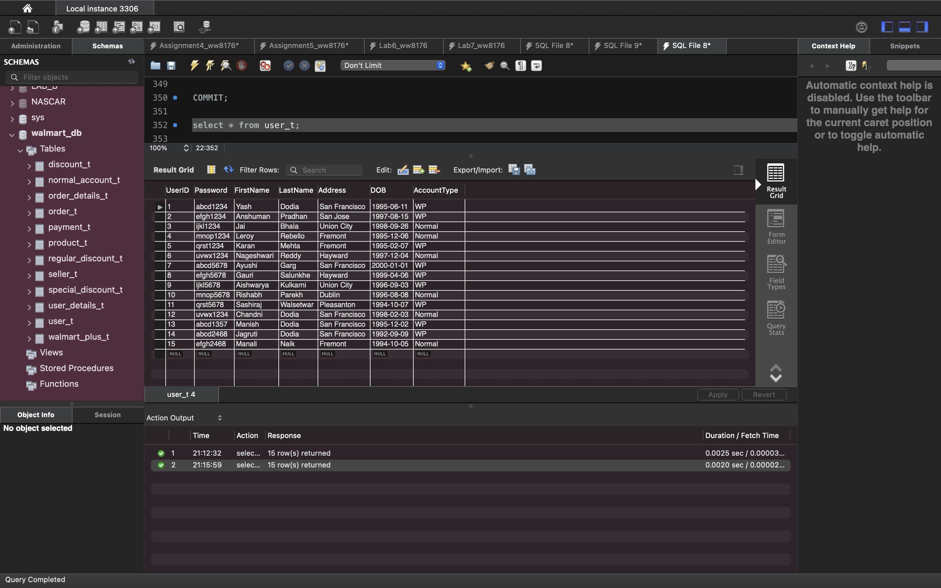

* 1. **Alter Table**

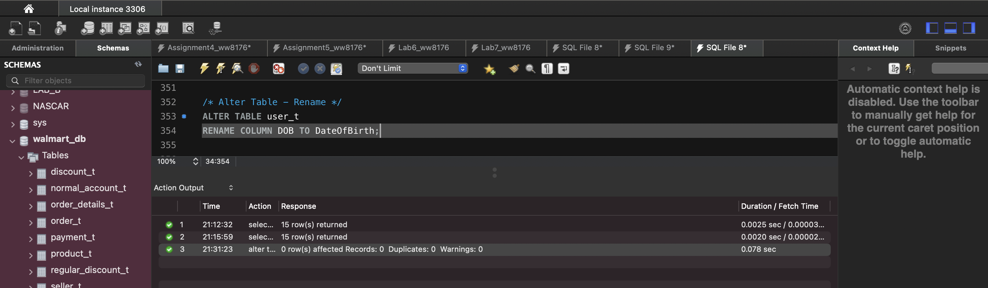

* 1. **Drop Table**

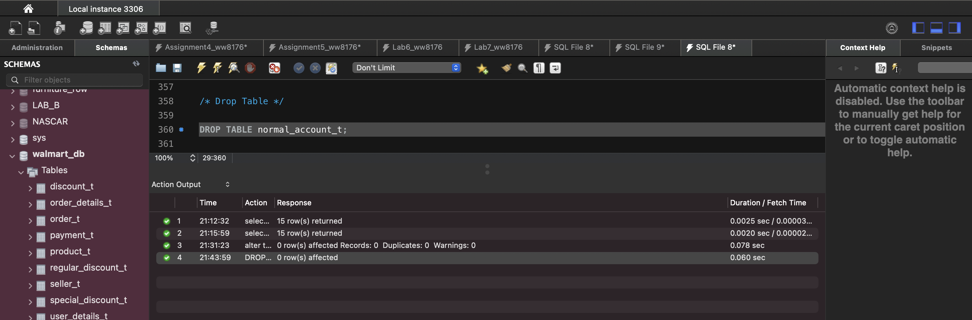

* 1. **Rename Table**

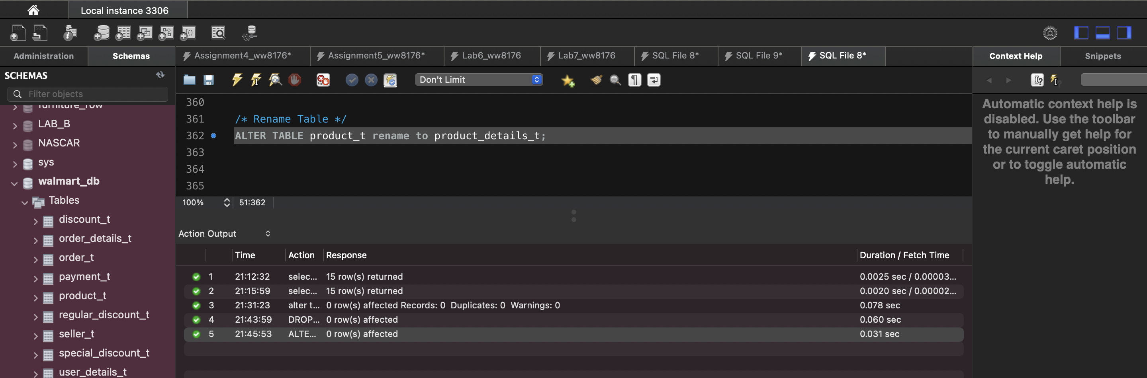

1. **SQL DML Statements**
   1. **Insert Records**

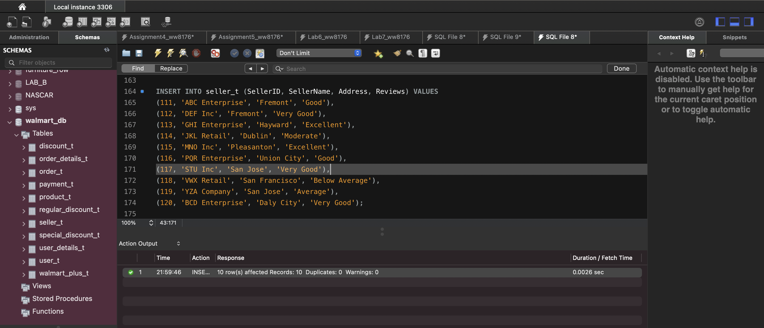

* 1. **Update Records**

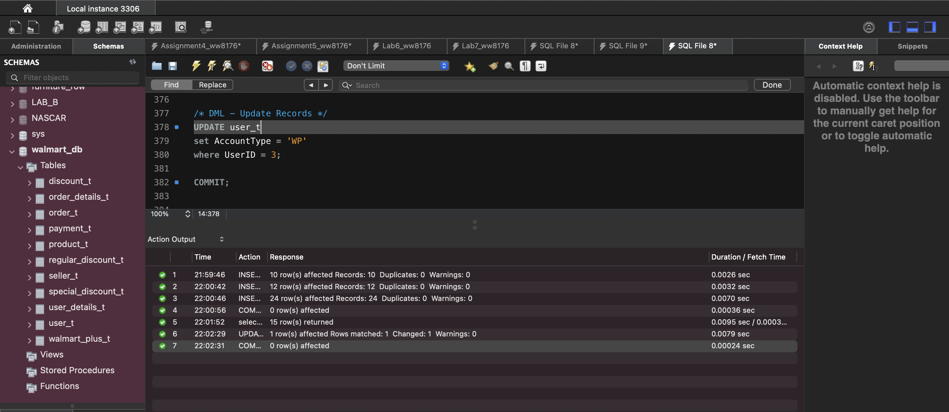

* 1. **Delete Records**

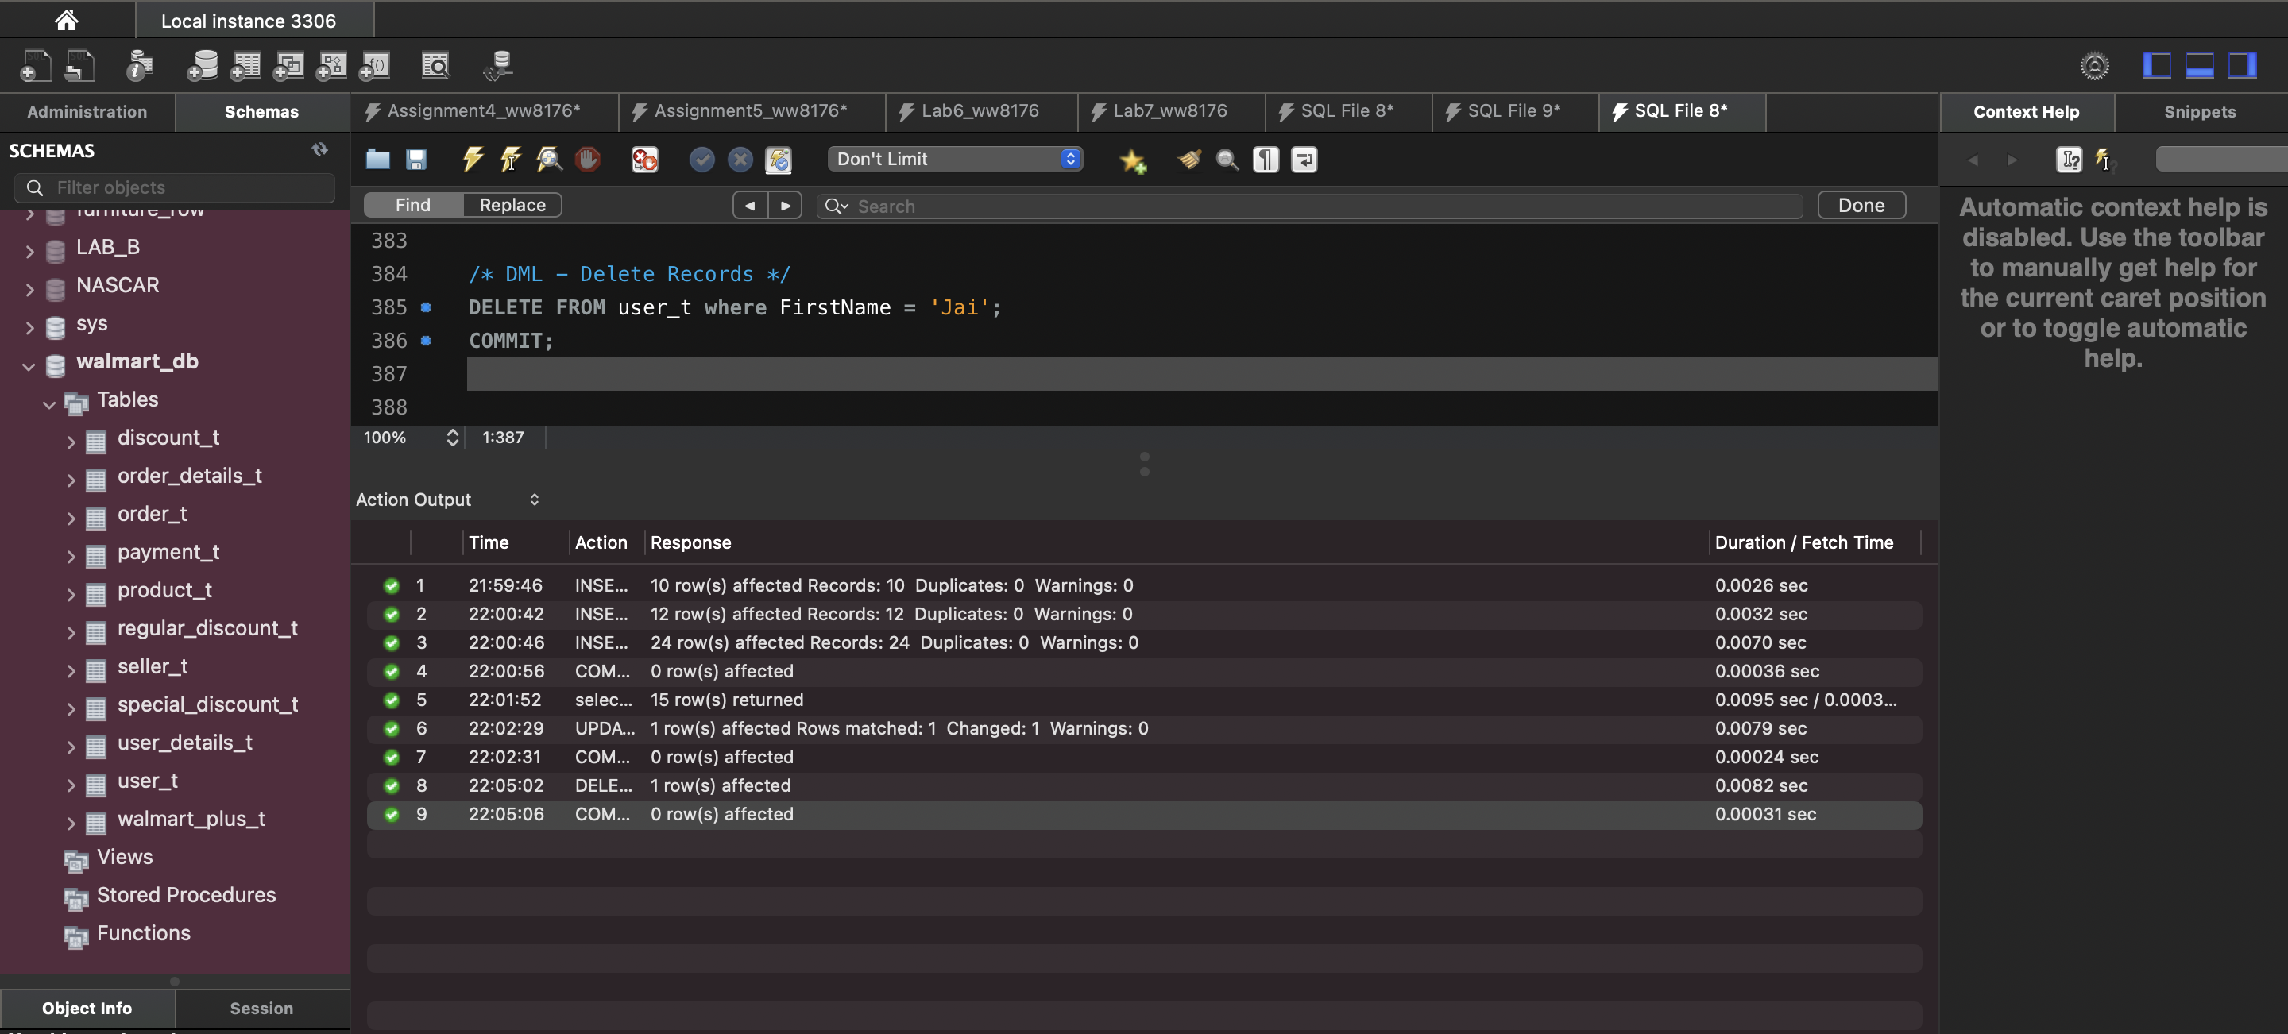

* 1. **Select Records**

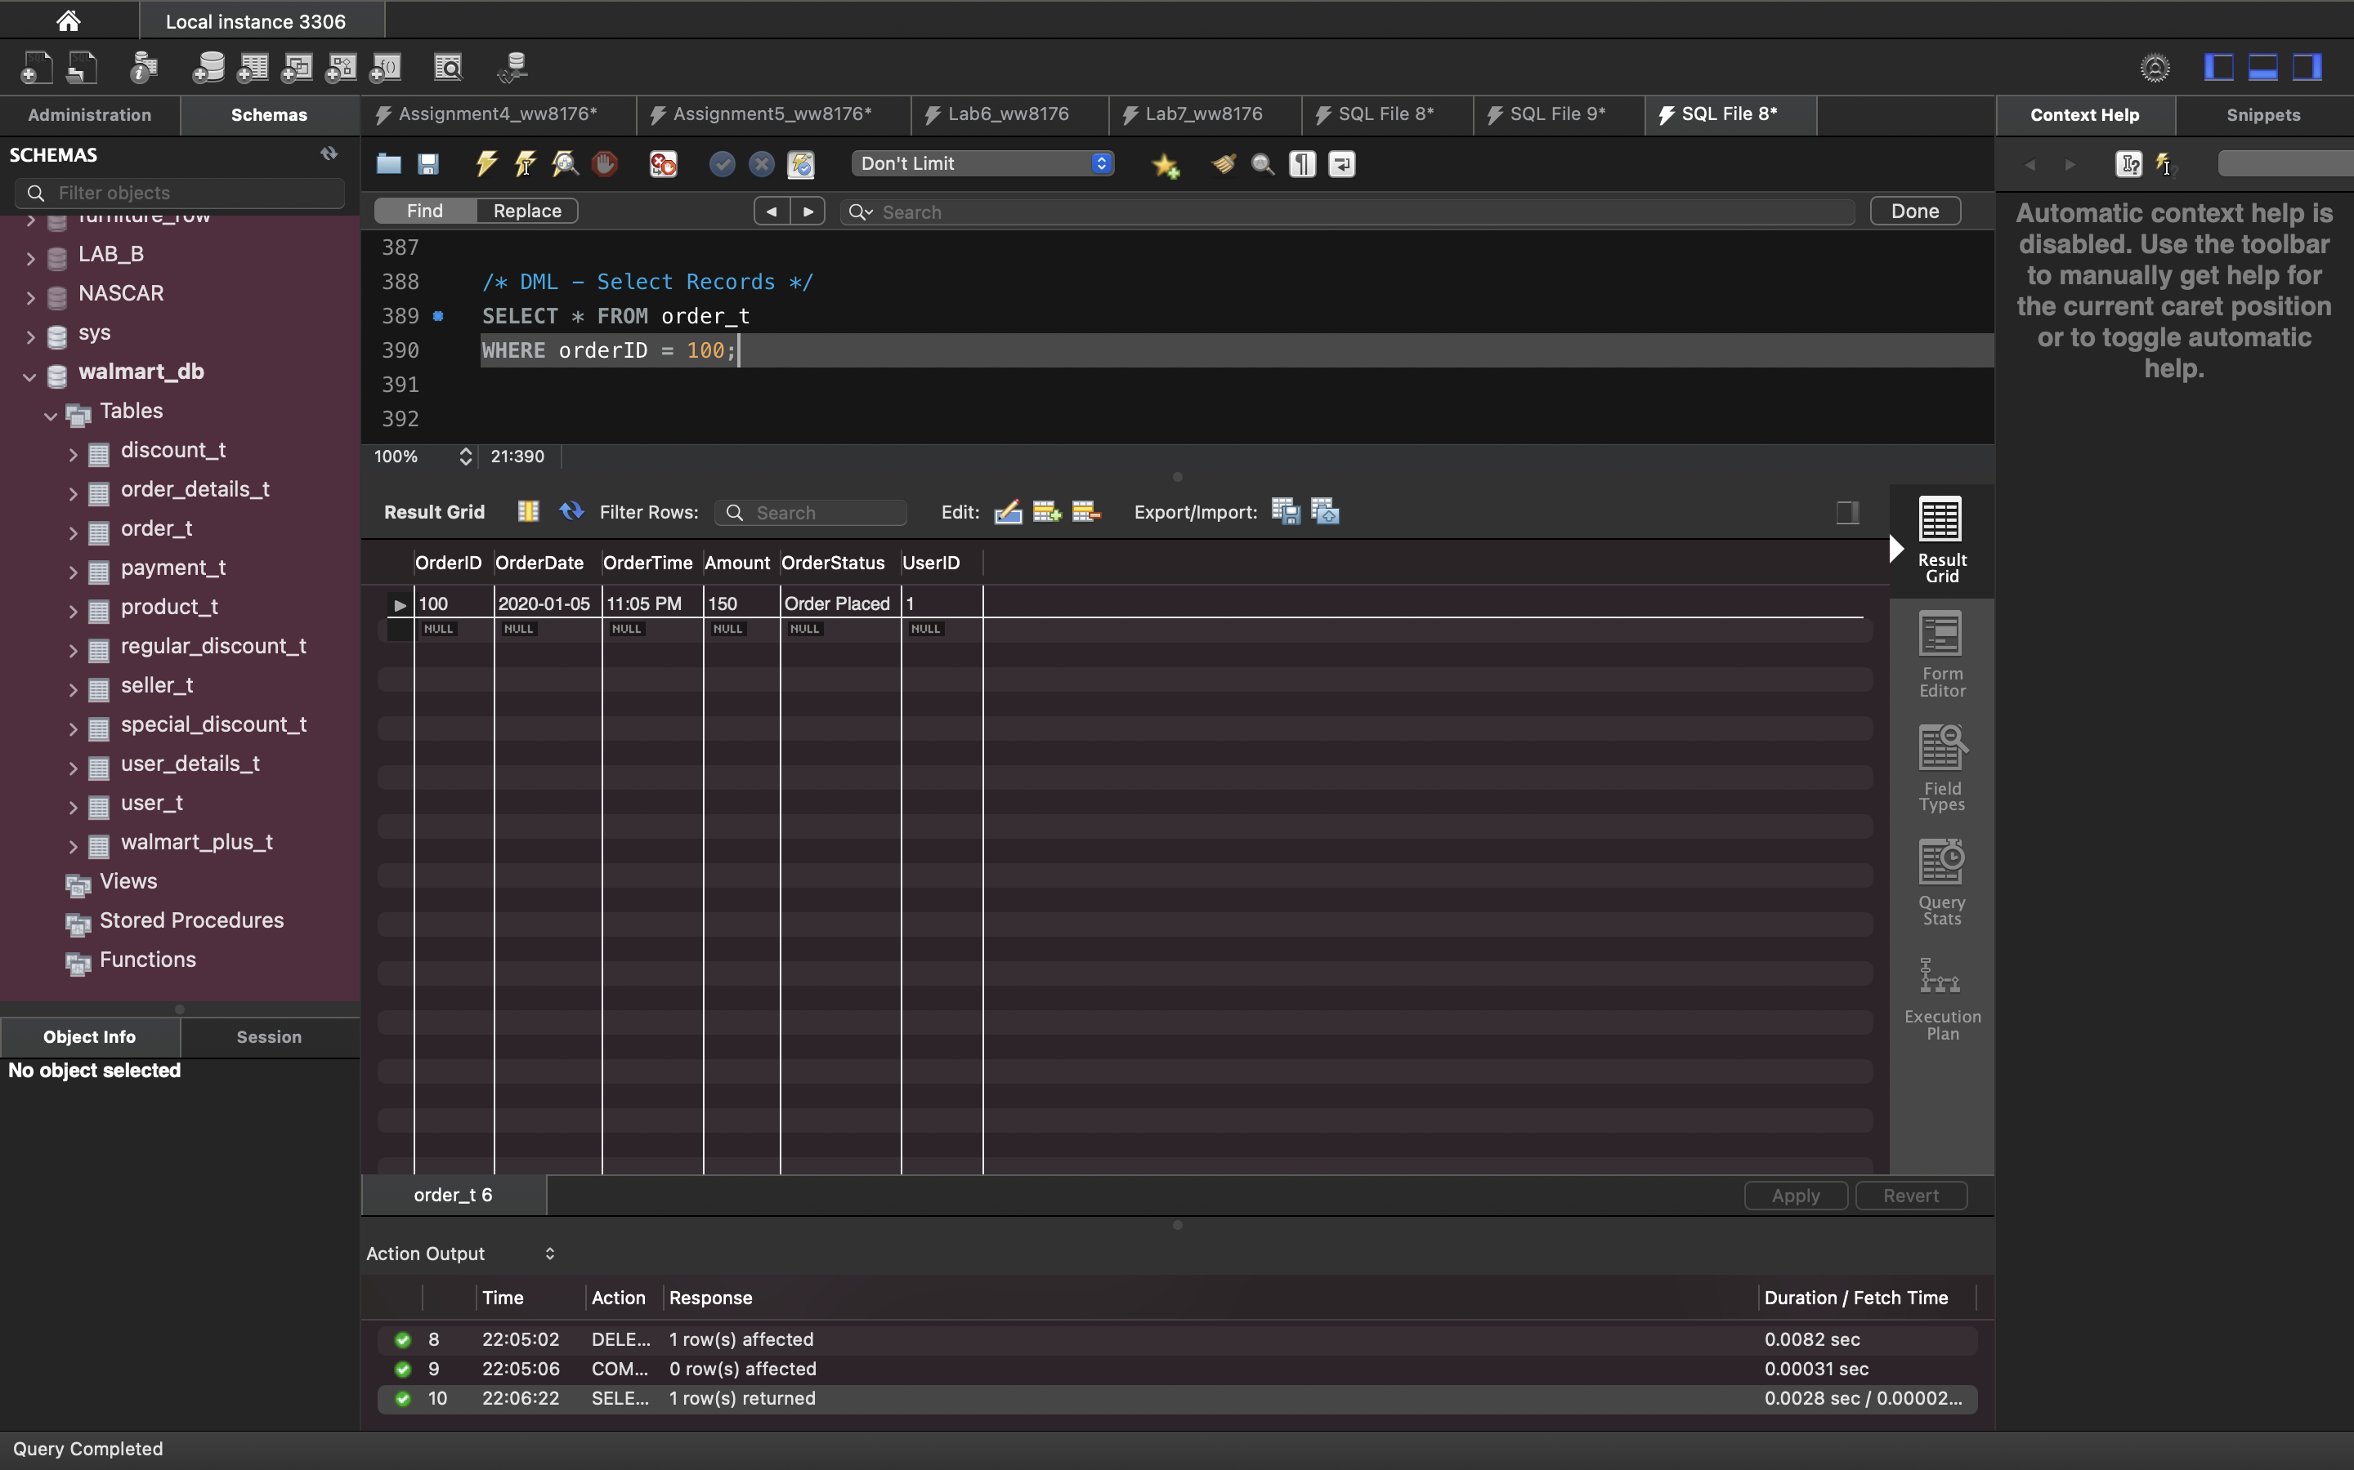

1. **SQL Joins between tables**
   1. **Natural Join**

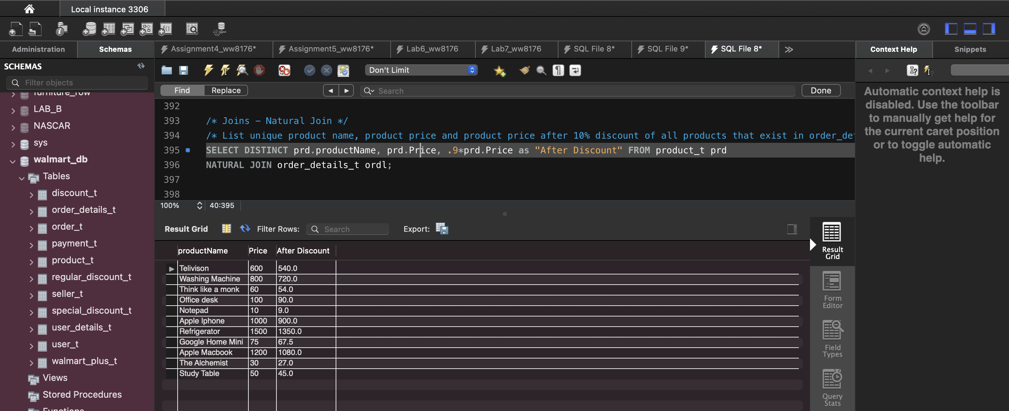

* 1. **Inner Join**

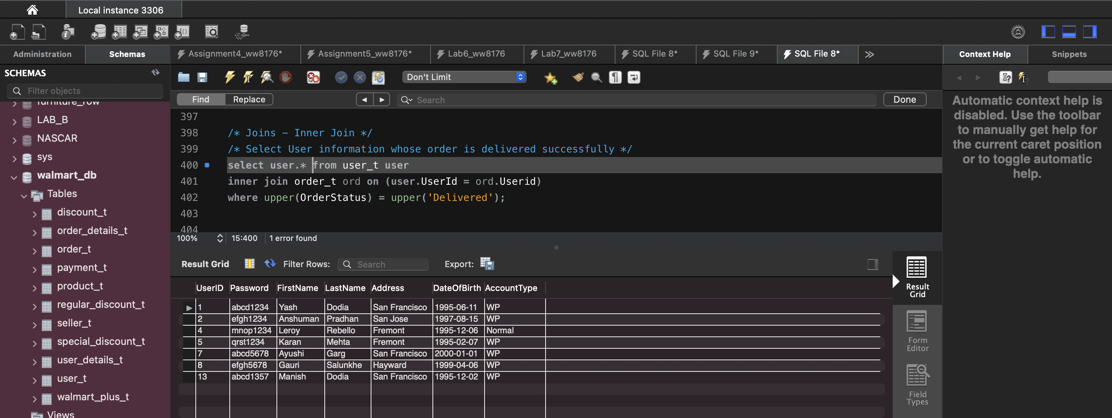

* 1. **Left Join**

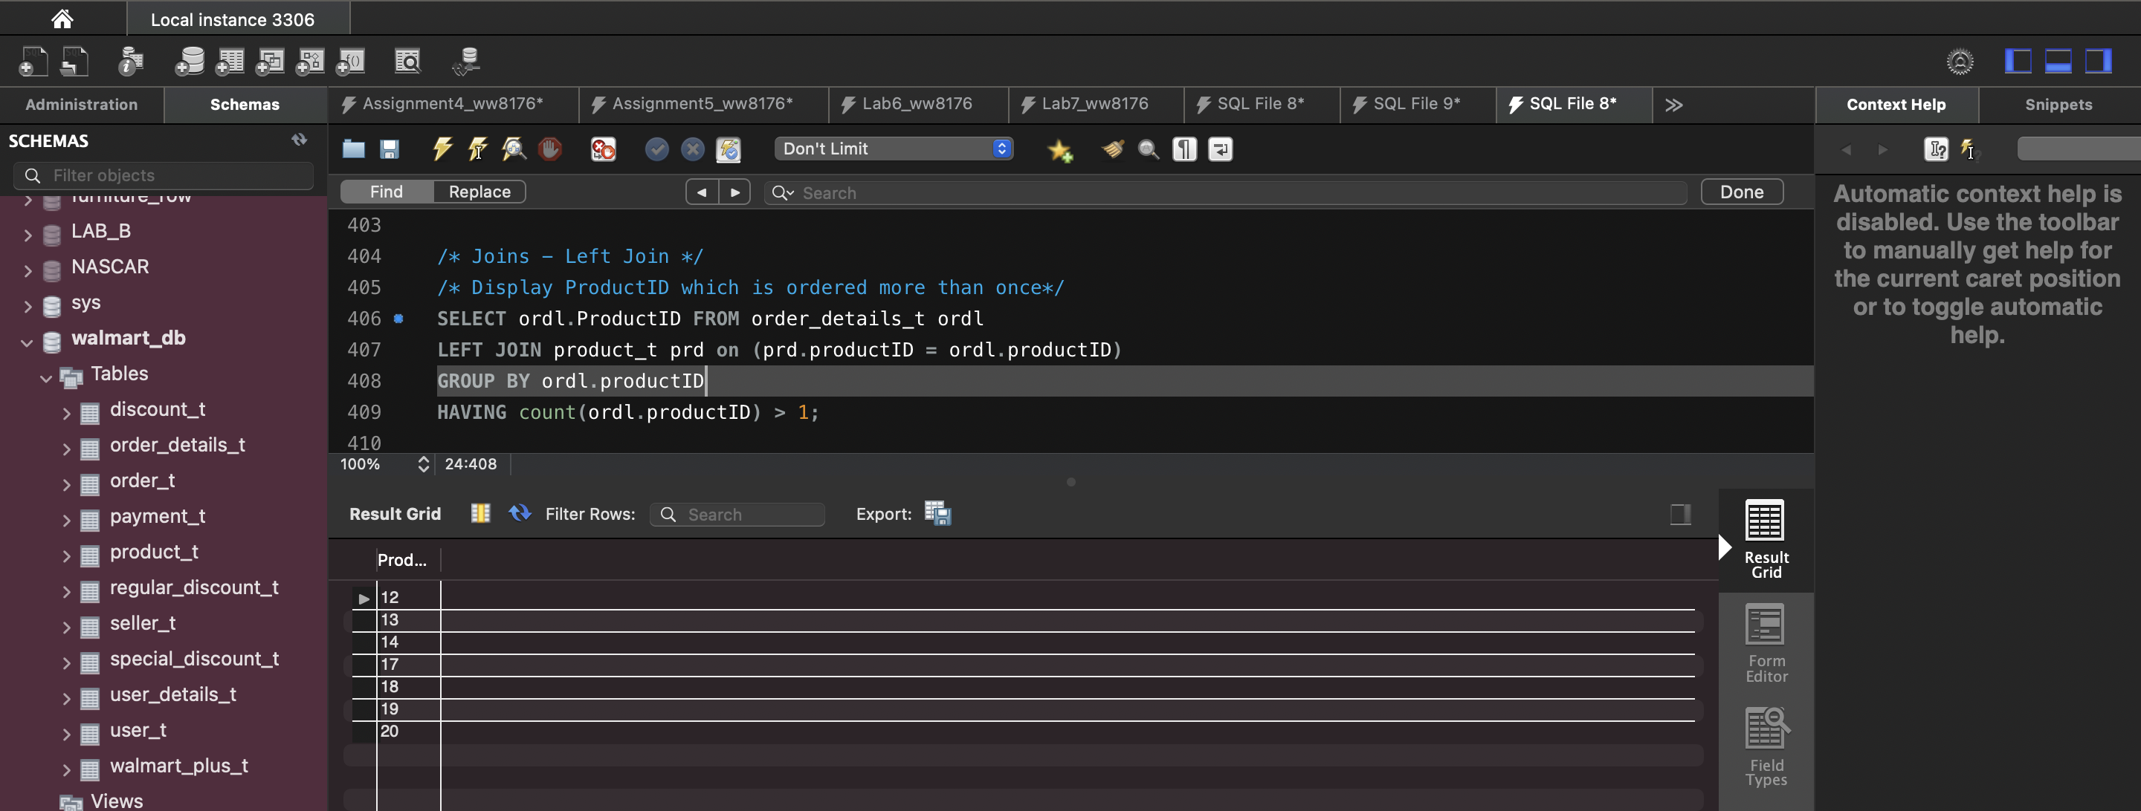

* 1. **Equi Join**

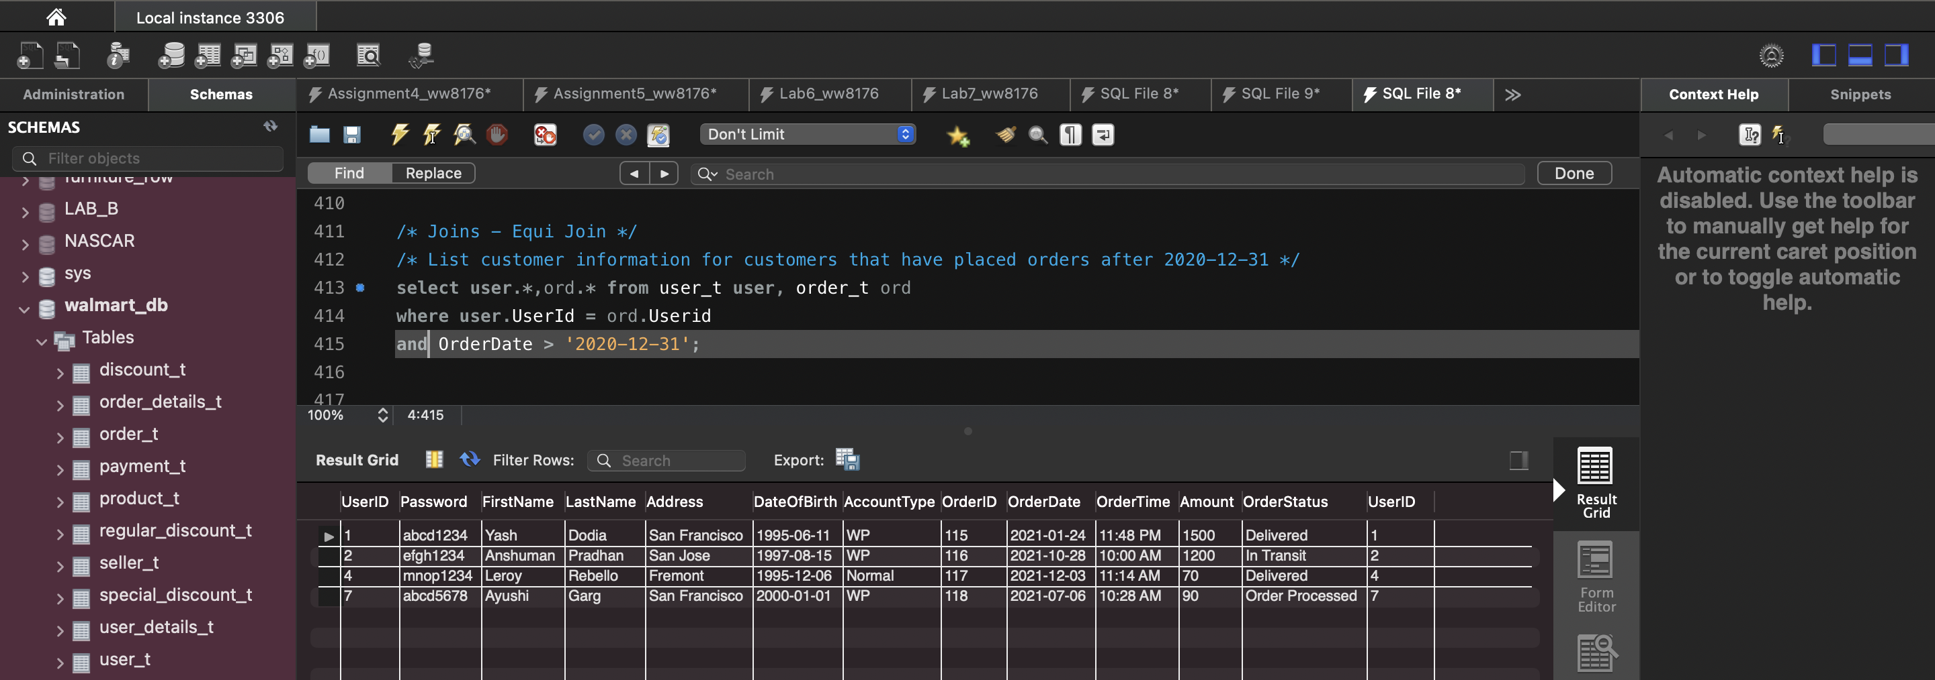

1. **Views**

